**Mrs.Raulerson- Week 5 and week 6 Assignment** Creating 2Dart,Creating Studio Art 2

**Radial Balance and Crystallographic Balance**-.

Just like the last assignment, read the **handout** first (Next Page). Then, I encourage you to go out into your yard or find interesting things around your house and take photographs of objects that catch your eye and demonstrate **Radial** and **Crystallographic** balance. **\*Note\*** you are required to take 2 photographs for each type of balance. The 1st photo is your composition, the 2nd photo (Evidence Photo) is your composition with a piece of paper in it that includes your name and the type of balance it uses. Please make sure that you take time and consider the ideas in the handout when creating your composition and that is evident that time was spent and careful consideration was taken when your art was being made. Most likely you will have to take numerous photos and then choose your best ones to turn in for a grade.

\***If you do not have the technology available to take a photograph and turn it in digitally, or prefer to draw your assignment, you may do two small drawings of something you discover that demonstrate Radial and Crystallographic balance and turn it in. If you cannot turn it digitally you may turn it in with the cover sheet from your packet, to the drop-box in front of Leon.**

**My Examples of what to turn in:**

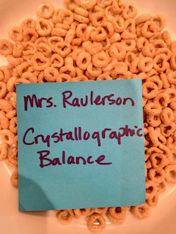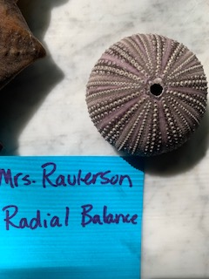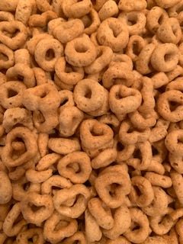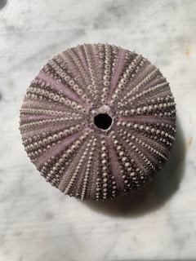

**\*Patterns on Fabric would also be good for Crystallographic balance (all over balance)**

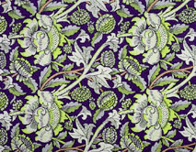 EX.

WEEK 5&6 HANDOUT

**Radial Balance**

In radial balance, elements radiate out (in a circular shape) from one main center point. If you’re looking to create a strong focal point, radial balance is an effective technique because your eyes are naturally drawn inwards to the center.

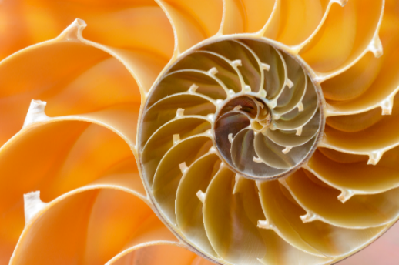

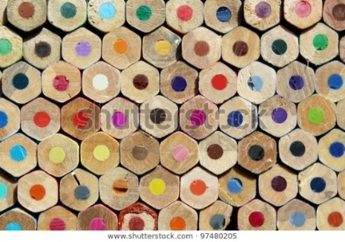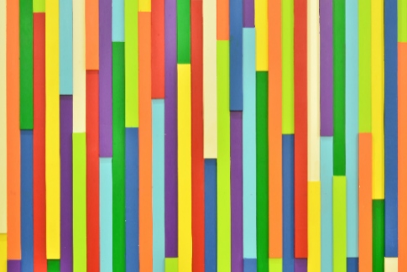**Crystallographic Balance**

Also called mosaic or “allover” balance, this type of balance is about repetition. At first glance, images employing crystallographic balance can seem random and chaotic; it might look like visual noise since you can’t identify a distinct focal point or visual hierarchy right away. But believe it or not, it works.

Remember, repetition and consistency are [major design principles](https://www.shutterstock.com/blog/8-common-design-mistakes-and-how-to-avoid-them), and by evenly repeating elements with equal weight throughout the design, it actually creates a sense of balance. You can see that the same colors, shapes, and sizes are repeated throughout each image. The wall repeats the same bright, bold colors; the colored pencils all have the same hexagon shape; the doughnuts are all uniformly sized. Wherever you look, you’re consistently seeing the same visual weight.

Balance is an important principle in many aspects of our lives, and it applies to design too. If your design lacks balance, it can feel “off” and ineffective. When you’re designing, don’t just stick to pure, static symmetry; try experimenting with different kinds of balance and playing around with visual weight. See what works best for your brand, project, and tone. You might find that you can use balance and symmetry in new, exciting ways that you’ve never used before.